TOTP Step-by-Step
Important Notice – You need two devices for this MFA type. Laptop/Tablet/iPad and a mobile phone to scan QR Code.
If you have not got Google or Microsoft Authenticator on your Mobile device please follow these steps to download it to your device.
Navigate to the app store on whatever mobile device you have.

Once you are in the app store, please download either Microsoft or Google Authenticator
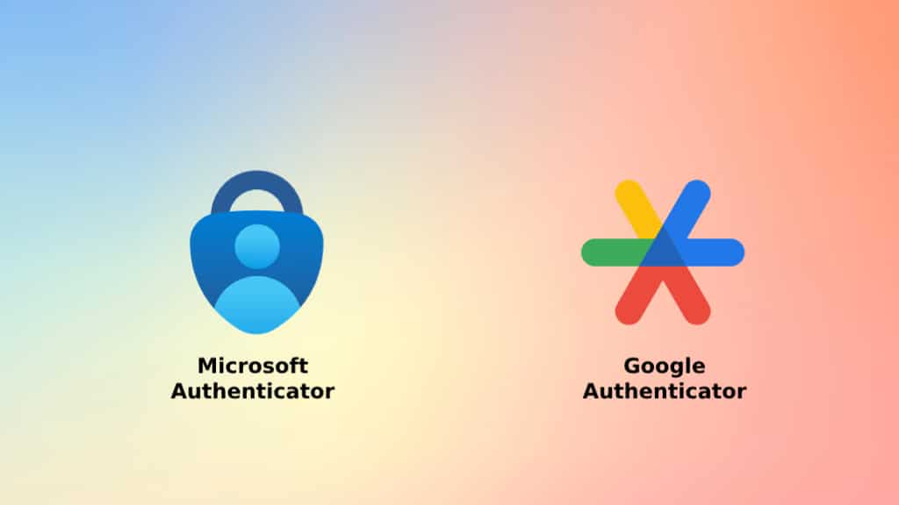
Microsoft Authenticator
Once the app is installed on your phone Accept the privacy permissions. Then the next page will ask to help to improve the Authenticator app but keep unticked and press continue. It will then give you the option;
- Sign in with Microsoft
- Add work or school account
- Scan QR Code
Click scan QR code
Google Authenticator
Once you have downloaded Google Authenticator open it up and click get started. You can either sign in with your email or continue without an account. Click the + button with the google colours and click Scan QR Code. You may need to accept permission for the Authenticator to use your camera. Once you have did this you are ready to go.

Instruction Page
The Process will not start until you click continue on the instructions page
Once you open the link you will be brought to the Instructions Page. Where it will tell you on the top right what method of MFA you will be doing. On the Instruction Page you will have the chance to watch a video demonstrating the task. It also gives you what you need to do in written terms as well.
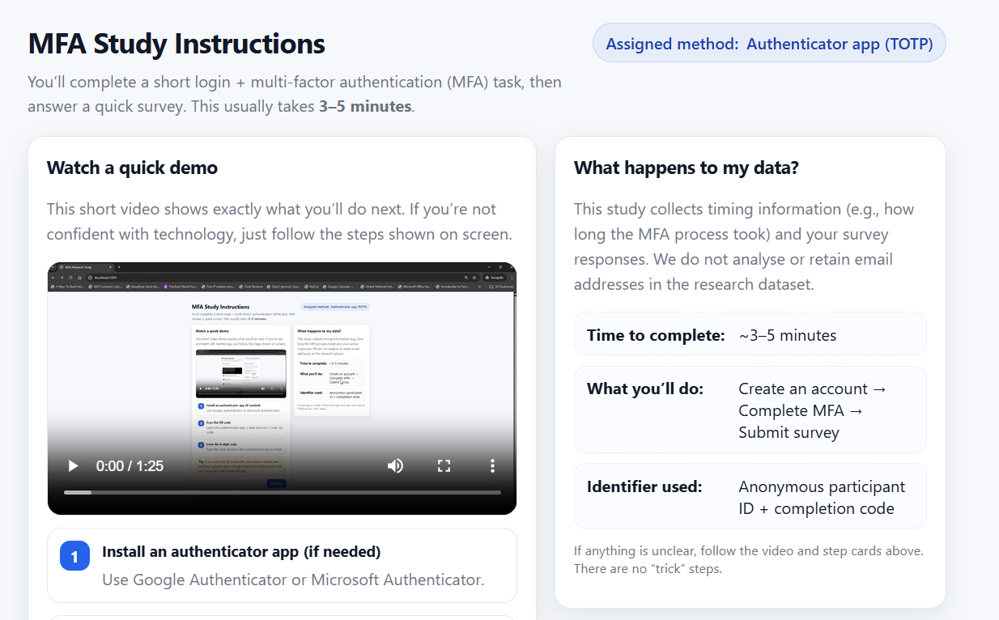
Then when you are ready to begin click the continue button.
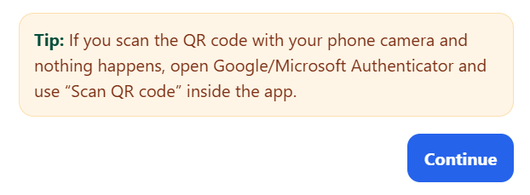

Sign-Up Page
Once you have pressed continue you will be brought to the Sign-Up page.
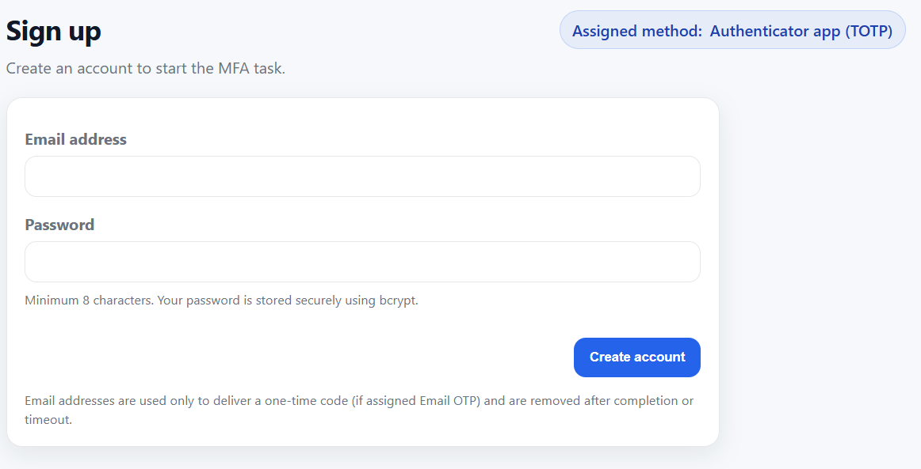
Please enter your email and then a password which needs to be a minimum of 8 characters. Your passwords are hashed but please do not use any passwords you normally use. Just use a random password for this process. Once you have entered a Username and password click create account.
Scan QR Code
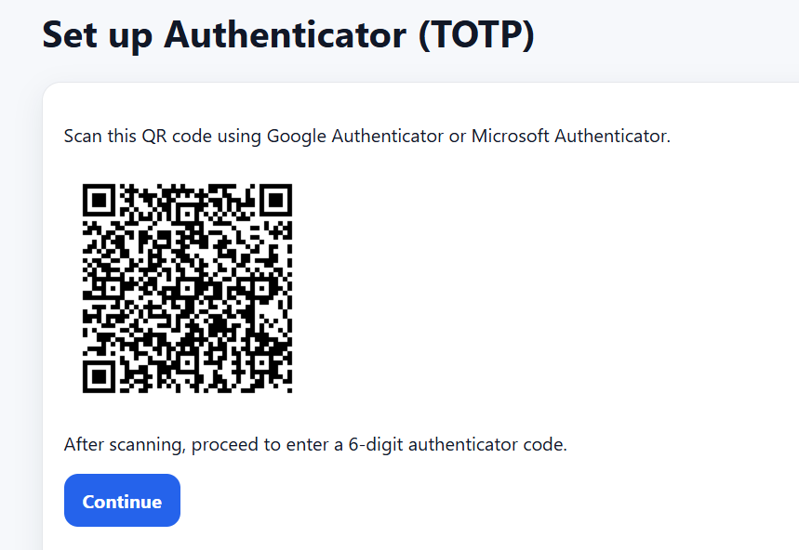
You will then be taken to the Authenticator Page; this is where you scan the QR Code. In your app click Scan QR code and then it should authenticate the user and provide them with a six-digit code.
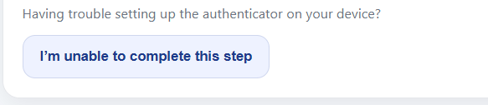
If you are unable to scan the QR code please do not worry, click the ‘Im unable to complete this step’ button which will take you to the questionnaire. You will be asked the same questions with extra down the bottom about your difficulties.
Authenticator Code Page
Once you have successfully scanned the QR code enter the six digit code presented on your Authenticator app.
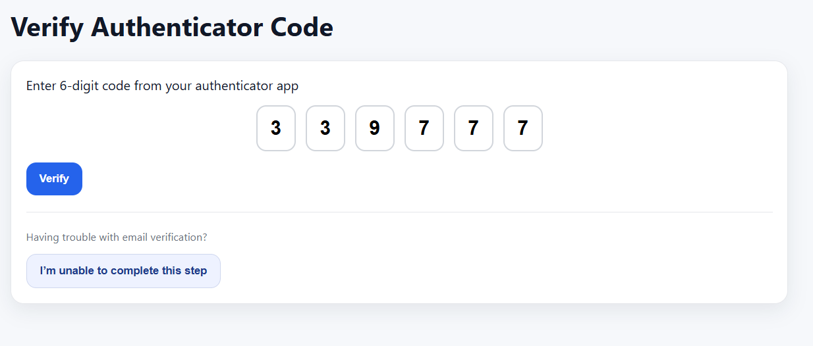
Questionnaire
You will then go to the questionnaire page. You will all be given a unique completion code on the page but you don’t need to worry about entering the code into Q1 as it has already been done for you.
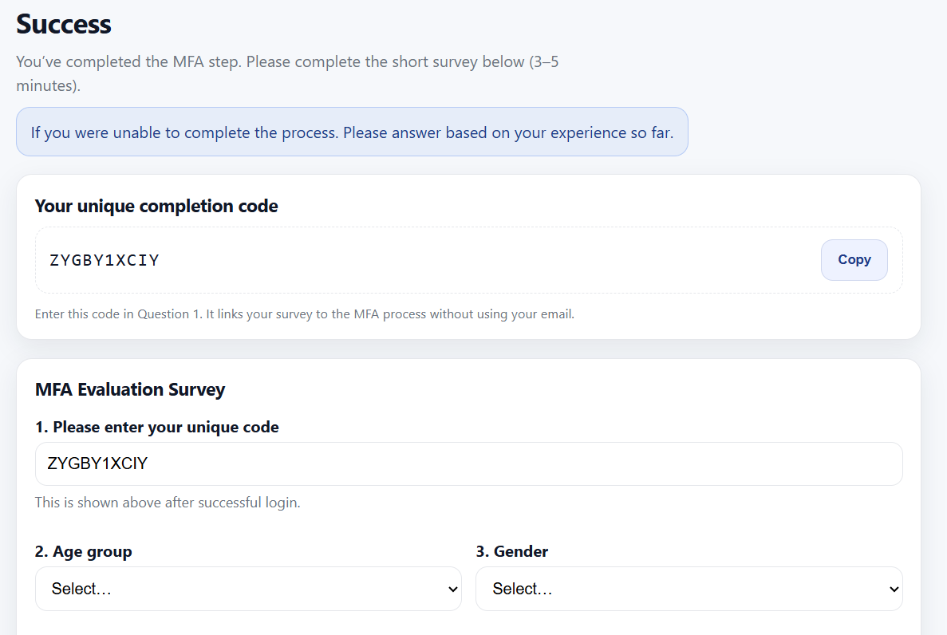
Answer all the questions accordingly and once you have completed the questionnaire click the submit button.
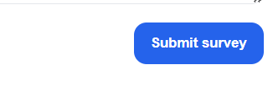

Thank You page
When you click submit you will then be brought to the Thank you page and you will see that your questionnaire response has been successfully submitted. Thank you to everyone who takes their time out to participate it means a lot.
